My Roots in Community Banding
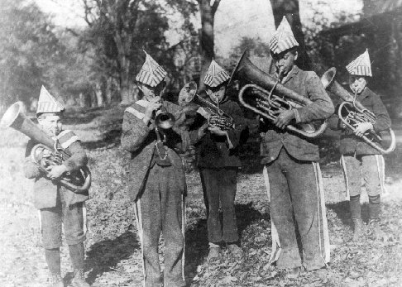

I suppose my roots in community banding go back a ways. My Grandmother’s Grandfather owned a music store. The photo is of the Deerfield (Mass) Boys’ Band in 1896, founded by my Grandmother’s brother, Ned Lamb (the tall baritone player). Note the paper hats and sewn-on stripes on the knickers. It was Ned’s uncle Bert Thompson who first taught me to play drums, and I still have the ebony drumsticks which he used as a boy in the late-1870s.
My parents met at a community band concert, and a major summer recreation for the family was going to community band concerts in the various hill towns in Western Massachusetts in which my father played trumpet. I always hung around the back of the bands, so I could see all the instruments being played, without the music stands getting in the way.
The holiday season often reminds me of the old May Family Brass Choir. With my father on trumpet, oldest brother on trumpet or euphonium, me on trombone, and youngest brother on tuba, we would stroll door to door in our neighborhood playing Christmas carols, That was a tradition which I miss greatly, both for the family fun, and for what it said about small-town neighborhoods.
Our sister, Becky, was too young to participate, but later developed her own singing talents. Our 2nd oldest brother carried a tuba in the high school band. I say “carried a tuba” because he was specifically prohibited by the director from carrying a tuba and a mouthpiece at the same time, for fear that he might actually try to play! It seems that he had inherited our mother’s level of musicianship.
These roots in community banding help me realize the value of bands such as MVCB. And they are also why it’s a thrill to carry on the May-Lamb family tradition by playing in a community band with my son.
Written for the December 1998 MVCB Newsletter

